**Lion is again on Hunt!!!**

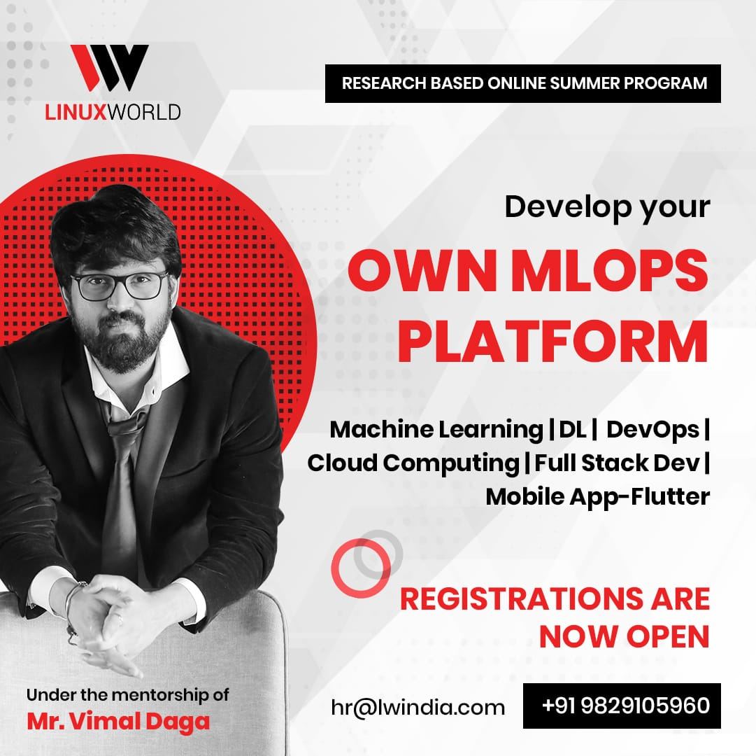

**Research-based Summer Program by**

**SIR VIMAL DAGA**

**🌐 Machine Learning | Deep Learning | DevOps | Cloud Computing | Full Stack Development |Mobile Application - Flutter and much more....**

**👨🏻‍💻 Integrating multiple technologies to get hold of this changing industry.**

**📢 Applications Open Now to dive into the world of technologies.**